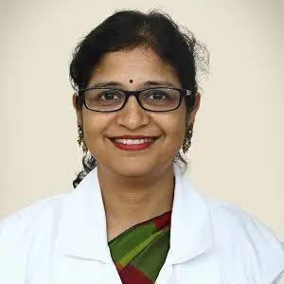

Dr Janani Iyer
MD,FRCOG(UK), CCT (UK), ATSM., Fertility Medicine
Consultant Gynaecologist, CURI Hospital

Dr Janani Iyer is a senior obstetrician and gynaecologist at CURI Hospital with an experience of 22 years in this field. She attained her MBBS and MD in obstetrician and gynaecologist from Maharaja Sayajirao University and Medical College, Baroda. She has attained CCT and FRCOG from the UK where she practised for 14 years. She also did her training and research in sub fertility at the Newcastle University,UK. She was a former consultant in the UK.

Her areas of expertise are:

Male and Female sub fertility treatments including ultrasound, laparoscopy and assisted reproductive including IVF, general and adolescent gynecological problems, high risk obstetrics and menopause.

